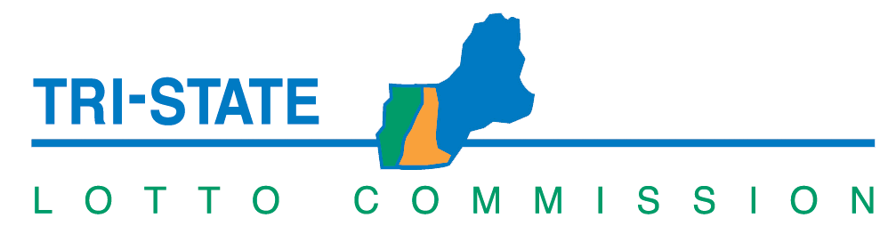
TRI-STATE COMMISSION MEETING AGENDA
June 27, 2024 – 9:30 a.m.
New Hampshire Lottery
Microsoft Teams

1. Proposal for Tri-State Draw Services
2. Next Meeting – Friday, August 9, 2024

Microsoft Teams
Join the meeting now
Meeting ID: 265 974 634 149
Passcode: QraFJQ
Dial in by phone
+1 603-931-4944,,861857491# United States, Concord
Find a local number
Phone conference ID: 861 857 491#
Join on a video conferencing device
Tenant key: nhgov@m.webex.com
Video ID: 113 719 389 3

